DST launches INR 15 Crore fund to support India-Russia collaboration joint R&D and cross-country technology adaptation
The Department of Science and Technology has launched the India-Russia Joint Technology Assessment and Accelerated Commercialization Programme in partnership with the Federation of Indian Chambers of Commerce and Industry (FICCI) and Foundation for Assistance to Small Innovative Enterprises (FASIE) of the Russian Federation. The programme will connect Indian, and Russian Science & Technology (S&T) led SMEs and Start-ups for joint R&D for technology development and for cross-country technology adaptation.

Speaking at the launch on July 23, 2020 here, Prof. Ashutosh Sharma, Secretary, Department of Science and Technology, Govt. of India said that India and Russia have a long-standing bilateral scientific cooperation. The launch of the India-Russia Joint Technology Assessment and Accelerated Commercialization Programme is another step towards strengthening the Science, Technology and Innovation ties between the two countries. This initiative is very timely, wherein we can leverage joint intellectual and financial resources to develop technologies that would provide the solutions for tomorrow. He wished the programme a huge success.

Shri D.B. Venkatesh Varma, Indian Ambassador to the Russian Federation, said “India has one of the largest startup ecosystems in the world, the number of unicorns is testament to the tremendous talent the country possesses. S&T-led innovation and entrepreneurship are priorities of both countries and will be a key point on the agenda as President Putin visits India later this year. There is a history of scientific cooperation between the countries, and with this initiative; we take the next step of commercialization.”

Shri Sergey Polyakov, General Director, Foundation for Assistance to Small Innovative Enterprises (FASIE), Russia said “We are extremely happy to launch the India-Russia Joint Technology Assessment and Accelerated Commercialization Programme. We are aware of the knowledge and expertise of India in the larger science, technology, innovation and entrepreneurship ecosystems and our extremely happy to partner with India on this programme. We hope the innovations and technologies supported through this programme will be help us face and overcome the challenges in this new normal.”

Shri Dilip Chenoy, Secretary-General, FICCI stated “The launch of the India-Russia Joint Technology Assessment and Accelerated Commercialization Programme today is a testimony of both country's commitment to further strengthen the S&T cooperation. This initiative will create an ecosystem for Indian and Russian S&T-led SMEs and startups to come together to develop new technological solutions. We are glad to announce the launch of this programme as we are certain that collaborations such as these will help both countries move towards revival of the economies leading to sustainable growth.”

Shri SK Varshney, Adviser & Head, International Cooperation DST stated that both countries have been working for many decades in areas of science & technology cooperation resulting into knowledge generation, proto-type development and institution built up. There was a need to convert knowledge into products, and such a program would connect Indian and Russian scientific & production houses, researchers, entrepreneurs to address societal challenges, not only of two countries but globally.

The programme will run through two annual cycles with up to five projects to be funded under each cycle. Projects are being sought on leading S&T focus areas, including but not limited to, IT & ICT (including AI, AR, VR), Medicine & Pharmaceuticals, Renewable Energy, Aerospace, Alternative Technologies, Environment, New Materials, Biotechnologies, Robotics and Drones. On behalf of DST, FICCI will implement the program in India.

Over a period of two years, the Department of Science and Technology will fund up to INR 15 Crores to ten Indian SMEs/Start-ups and FASIE will provide similar funding to the Russian projects. The programme will provide access to partial public funding for jointly selected projects with the participation of at least one start-up/SME from India and one SME from Russia. The selected projects will be required to bear partial funding as well, either through own funds or alternate sources of funding. In addition to the financial support, the teams will also be supported through capacity building, mentorship and business development.
The programme is accepting applications under two broad categories, i.e. Joint Partnership Projects and Technology Transfer/Adaptation. The last date to apply for the first round of the call is September 30, 2020. A dedicated portal www.indiarussiainnovate.org has been developed for this purpose.

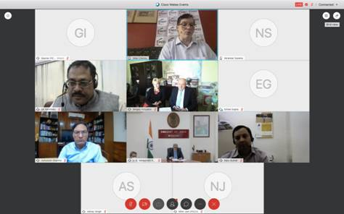

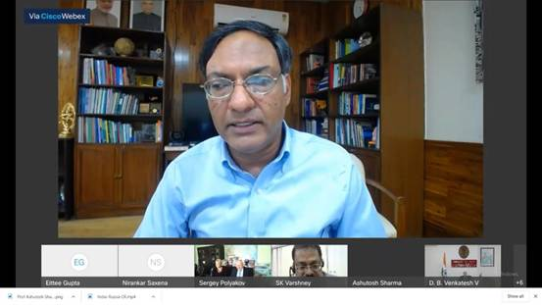
**

Source
Press Information Bureau, 24 July 2020

